**Prediction of Tesla Stock Price Using Machine Learning**

Author: Hang Yong Jin

Abstract

Stock price prediction has long been a domain of interest in quantitative finance and data science. With the rise of deep learning, models like Long Short-Term Memory (LSTM) and Gated Recurrent Unit (GRU) networks have shown promising results in time-series forecasting tasks. This project aims to build and compare three models—LSTM, GRU, and a hybrid LSTM-GRU—to forecast Tesla Inc. (TSLA) stock prices. The evaluation is performed using metrics such as Mean Squared Error (MSE), Root Mean Squared Error (RMSE), and R-squared (R²). Our results indicate that the hybrid LSTM-GRU model outperforms individual architectures in capturing both short-term fluctuations and long-term trends.

Contents

Abstract 1

1. Introduction 3

1.1. Background Reading 3

1.2. Problem Statement 3

1.3. Objectives 3

2. Methodology 4

2.1. Overview 4

2.2. Dataset Description 4

2.3. Assumption 5

2.4. Architecture Diagram 6

3. Result and Evaluation 7

3.1. Data Insights 7

3.2. Model Comparison Table 7

3.3. Future Work 8

4. Conclusion 9

5. Appendix 9

1. Introduction
   1. Background Reading

Stock price forecasting is crucial for investors and financial institutions. Traditional methods like ARIMA and moving averages are limited in handling non-linear patterns and long-term dependencies. Recurrent Neural Networks (RNNs), specifically LSTM and GRU, are well-suited for sequential data due to their memory retention capabilities. In recent years, hybrid models have gained attention for their ability to combine the strengths of individual architectures.

* 1. Problem Statement

The stock market is inherently volatile and influenced by numerous dynamic factors, making accurate price prediction a highly challenging task. Traditional statistical methods often fail to capture complex temporal dependencies and nonlinear patterns present in stock market data. As a result, there is an increasing need to explore deep learning-based approaches that are capable of learning from historical sequences and extracting meaningful trends. This project addresses the problem of predicting Tesla's stock closing price by leveraging recurrent neural network architectures—specifically LSTM, GRU, and a hybrid LSTM-GRU model. The goal is to evaluate the effectiveness of each model in capturing sequential dependencies and forecasting stock prices with improved accuracy and reliability.

* 1. Objectives
* To collect and preprocess Tesla’s historical stock data.
* To develop and train LSTM, GRU, and hybrid LSTM-GRU models for time-series forecasting.
* To evaluate and compare the models using MSE, RMSE, and R² metrics.
* To analyze model performance and provide recommendations for future improvements.

1. Methodology
   1. Overview

The project follows a standard data science lifecycle:

1. Data Collection: TSLA historical stock data from Yahoo Finance.
2. Preprocessing: Feature engineering, scaling, and train-test split.
3. Model Building: LSTM, GRU, and hybrid LSTM-GRU using TensorFlow/Keras.
4. Evaluation: Performance comparison based on statistical metrics.
5. Visualization: Forecast vs. Actual trend analysis.
   1. Dataset Description

* Source: Yahoo Finance
* Ticker: TSLA
* Period: January 2010 to June 2024
* Features Used: Date, Open, High, Low, Close, Volume
* Target: Next-day closing price
  1. Assumption
* The stock market follows time-dependent sequential patterns.
* Only historical price data is used (no news sentiment or macroeconomic indicators).
* The models are trained on past data and tested on unseen future data.
* Data leakage is prevented by strict train-test temporal separation.
  1. Architecture Diagram

|  |  |  |
| --- | --- | --- |
| Tesla Stock Time Series  [Close, High, Low, Volume] | | |
| ↓ | | |
| Data Preprocessing   * MinMax Scaling [0, 1] * Sliding Window (t-60 to t-1) * Train/Test Split (80/20) | | |
| ↓ | | |
| Model Input Layer  Shape: (batch_size, 60, n_feat)| | | |
| ↓ |  | ↓ |
| LSTM Layer  (unit=64/128)   * Long memory * Gates: forget, input, output |  | GRU Layer  (units=64/128)   * Shorter memory * Reset/update gates only |
| ↓ |  | ↓ |
| Concatenation / Merge Layer  (for hybrid LSTM-GRU model) | | |
| ↓ | | |
| Fully Connected (Dense) Layer  - Activation: Linear  - Output: 1 unit (next price) | | |
| ↓ | | |
| Output: Predicted Price (t) | | |

1. Result and Evaluation
   1. Data Insights

* Tesla's stock prices demonstrated significant exponential growth, particularly from 2019 onward, reflecting increased investor interest and market confidence.
* The data exhibited seasonality and volatility spikes (e.g., during COVID-19).
* The correlation matrix revealed a strong autocorrelation in closing prices, suggesting that past values are highly predictive of future trends—an ideal characteristic for time-series forecasting using deep learning models.
  1. Model Comparison Table

|  |  |  |  |
| --- | --- | --- | --- |
| **Model** | **RMSE** | **MSE** | **R² Score** |
| LSTM | 16.968 | 287.909 | 0.950 |
| GRU | 12.681 | 160.805 | 0.972 |
| LSTM + GRU | 14.764 | 217.987 | 0.962 |

* GRU achieved the best overall performance, with the lowest RMSE (12.681) and MSE (160.805), alongside the highest R² score (0.972). This suggests that GRU is more efficient at capturing temporal dependencies in Tesla’s stock price data, likely due to its simpler gating mechanism and fewer parameters compared to LSTM.
* LSTM produced reasonable results, but with a higher error and a lower R² (0.950). This indicates that while it captures long-term dependencies, it may be more prone to overfitting or require more tuning.
* The LSTM + GRU hybrid model performed intermediately, with an RMSE of 14.764, suggesting that the hybrid did not outperform GRU alone in this setup. This might be due to increased model complexity leading to slightly less generalization, or suboptimal architecture or training configuration.

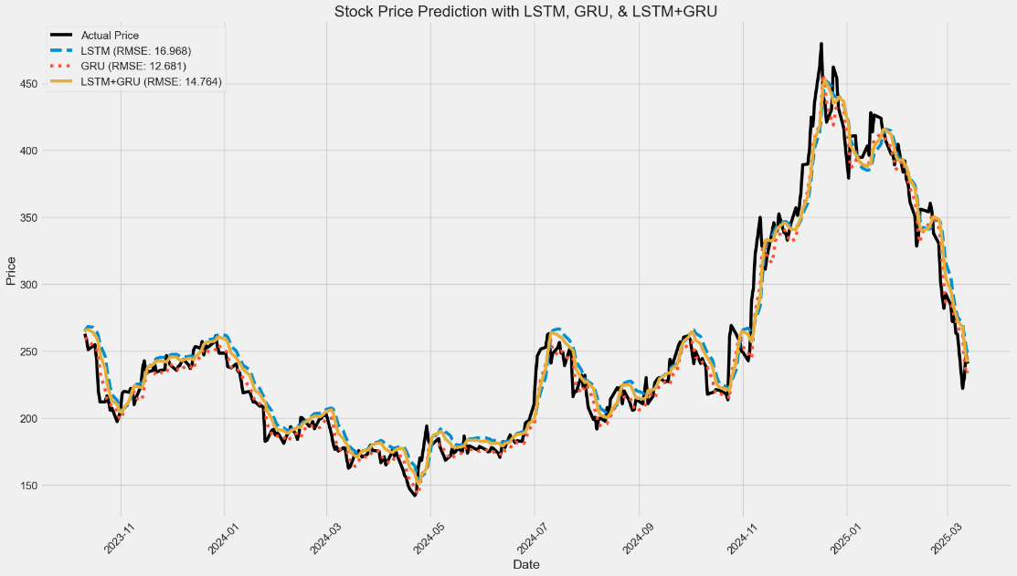

* GRU tracks the actual price most closely, especially during transitions and turning points. Its responsiveness during sharp increases (late 2024) and sudden declines (early 2025) indicates strong adaptability and temporal awareness, validating its superior RMSE and R² performance.
* GRU handles volatility and non-linearity better, likely due to its simpler architecture that helps prevent vanishing gradients and allows faster convergence.
* All models generally follow the stock’s upward and downward trends, indicating that they learned the temporal patterns reasonably well.
  1. Future Work
* Integrate external influences such as quarterly earnings, financial news, and broader economic indicators.
* Utilize advanced tuning techniques like Optuna or Bayesian Optimization to refine model parameters.
* Develop a real-time prediction service by deploying the model via FastAPI or Flask as an API.
* Investigate the use of cutting-edge Transformer models, such as Temporal Fusion Transformers, for improved forecasting.

1. Conclusion

This project explored the use of deep learning models—LSTM, GRU, and a hybrid LSTM-GRU—for forecasting Tesla’s stock prices. Among the models, GRU delivered the best performance with the lowest RMSE and highest R² score, indicating strong predictive capability. The dataset revealed key patterns such as post-2019 exponential growth, volatility spikes, and strong autocorrelation in closing prices. Despite fluctuations caused by external events like COVID-19, the models successfully captured temporal dependencies. This work demonstrates the viability of recurrent neural networks for financial time series prediction and provides a foundation for developing real-time stock forecasting tools with further enhancements in future work.

1. Appendix